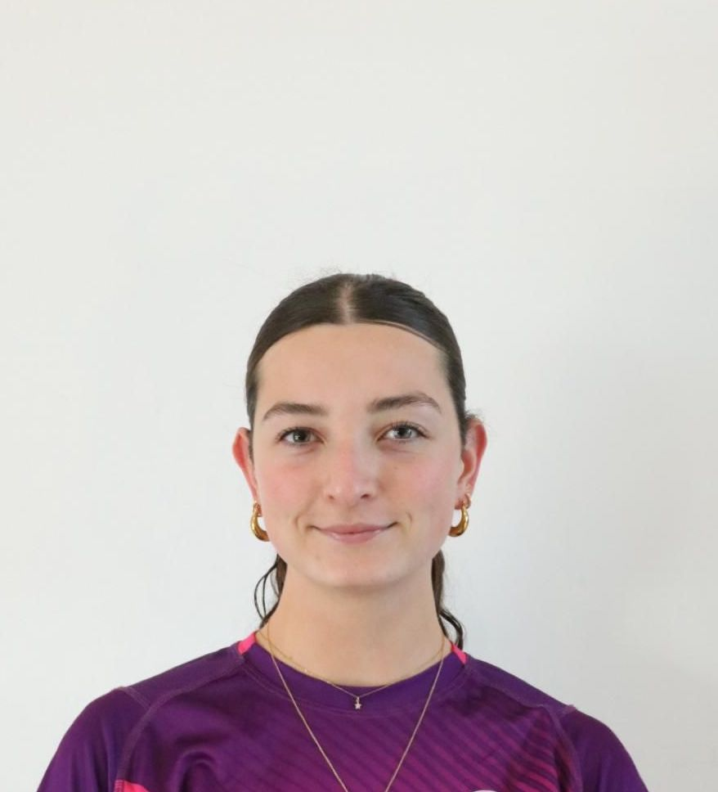
Alyssa DeSilva

SPORTING / PERFORMANCE RESUME
I am currently playing for Loughborough Students Women’s Hockey Club (LSWHC) in Loughborough, UK. Additionally, I am an overseas player for the Senior Women’s National Team.
LAST 5 YEARS ACCOMPLISHMENTS IN THE SPORT (national team tours, leadership positions)
2025/26
For LSWHC, this was a very successful season. I represented the club as Women’s Club Chair, an admin heavy role which required me to oversee the whole club (120+ members), coaches, university staff, external universities and companies such as BUCS and England Hockey. Additionally, I captained and played for the W4s. Through this season, we won BUCS league where we played other universities and finished the season undefeated which secured a promotion for next season. Through BUCS, we also won BUCS Conference Cup – a knockout cup run against other universities, where we finished the final 6-1. Finally, the W4s also placed first on the Midlands Division 1 EHL table, securing promotion into Midland Premier League for next season.
For Senior Women’s National Team, I was able to represent Bermuda in the CAC qualifiers in Mexico in May 2025. In this competition, we secured qualification for the CAC games in Dominican Republic in 2026.
For my community in Bermuda, I helped set up the U16 Summer program, coaching the next generation of hockey players during the summer. I also proposed a pre-college prep program, asking for pitch spaces and fitness sessions to ensure that Bermudian athletes had the potential to continue their sport during the off season.
24/25
Within LSWHC, I was on work placement so was able to take on more admin roles within committee. I travelled with our W1s to fixtures as their manager, as well as sitting on committee as IMS & Alumni Sec. As a player, I was able to play for a both W4s and W5s, but primarily W5s. While playing for the W5s, I was asked to be Vice Captain where we played in the BUCS Conference Cup run, where we finished second. For EHL, we finished second in Division 3 South East, securing promotion for next season due to finishing top 2. For the W4s, we also finished top 2 in Division 2 East in EHL, securing promotion.
For National team, I represented Bermuda in the PanAm Challenge in Bermuda in September 2024
23/24
For this season, I captained and played for the W5s. Although we were not successful in either BUCS league or EHL, we did manage to make the finals in the Knock-out “Women’s Tier 3 Championships”, held in Lee Valley in London. We were unsuccessful in winning, as we were playing the LSWHC W3s, but getting there regardless was a major achievement.
During this season, there was no official national team competitions.
22/23
During my first year at Loughborough University, I was able to make it into university hockey club. Although I was placed in the W6s, the lowest team, I was proud to have made a team regardless as I was in the top 40 of 150 trialists. As this was the first year of the W6s, there was only BUCS league to play and we were undefeated all season. My biggest achievement from this year was playing in All Stars weekend, hosted by the university, where we play a team of the best players who did not make a university team, where we won 5-1.
For Bermuda, the Senior Women’s National Team competed at the CAC games in Dominican Republic in July 2023. Although we were not successful in winning our pool, it was a fantastic opportunity to represent my country.
21/22
This season presented my first opportunity to represent Bermuda in hockey, playing in the CAC qualifiers hosted in Bermuda during April 2022. We were successful in winning the competition, securing us qualification for the next CAC games in 2023. I was also heavily involved in the community through coaching the FunStix program and playing in league for the Longtails.
GOALS FOR NEXT 2 YEARS IN THE SPORT
My goals for the next 2 years is to first continue my hockey development while studying a masters at the University of Edinburgh for 2026/27. For the Senior Women’s National Team, I hope to represent Bermuda in upcoming tournaments, such as the CAC games in Dominican Republic in July 2026.
I wish to also continue the development of junior programs within Bermuda Hockey Federation. Although this is difficult to achieve overseas, when I am at home I am hopeful that I will continue coaching and trying to facilitate programs.

